LAB 3 Exercises

- Basic: Create a Circle class with a constructor taking radius, and a no-argument constructor defaulting the radius to 1.0.
Code
public class Circle {
private Double radius;
// this is a constructor for the circle
public Circle(Double radius){
this.radius = radius;
}
// this is a constructor of circle without arguments with default radius 1.0
public Circle(){
this(1.0);
}
// creating a static counter that tracks how many circles exist with a
public static void main(String[] args){
// the is object c1 with no arguments
Circle c1 = new Circle();
// this prints out the default radius 1.0
System.out.println(c1.radius);
// this object has a radius of 2.3
Circle c2 = new Circle(2.3);
// prints out 2.3
System.out.println(c2.radius);
}
}
output

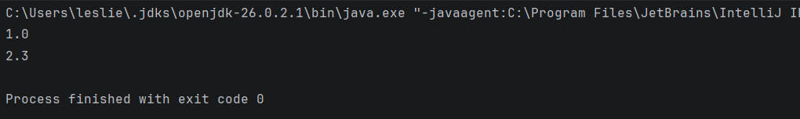

- Basic: Add a static counter to Circle that tracks how many circles exist, with a static getter.
Code
public class Circle {
static int count = 0;
private final int id;
private Double radius;
// this is an instance initialiser block runs before every constructor body
{
count++;
id =count;
}
// this is a constructor for the circle
public Circle(Double radius){
this.radius = radius;
}
// this is a constructor of circle without arguments with default radius 1.0
public Circle(){
this(1.0);
}
// creating a static counter that tracks how many circles exist with a static getter
public static int getCount(){
return count;
}
public static void main(String[] args){
// the is object c1 with no arguments
Circle c1 = new Circle();
// this prints out the default radius 1.0
System.out.println(c1.radius);
// this object has a radius of 2.3
Circle c2 = new Circle(2.3);
// prints out 2.3
System.out.println(c2.radius);
// this prints out the number of circles using the counter
System.out.println("Books :"+Circle.getCount());
}
}

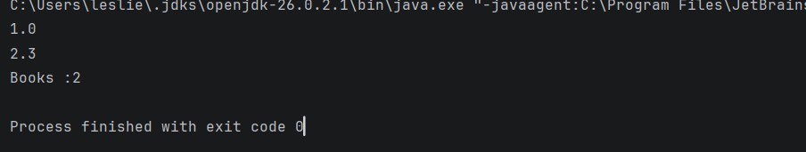
Output

- Intermediate: Write an Employee class with an auto-incrementing employeeId (use a static counter), three overloaded constructors and a copy constructor

Code

public class Employee {
// counter variable
static int count = 0;
// intance variables
private final int employeeid;
private String name;
private String department;
private Double salary;
{
count++;
employeeid =count;
}
// this constructor accepts all arguments
public Employee(String name,String department,Double salary){
this.name = name;
this.department= department;
this.salary=salary;
}
// this constructor accepts name and department with salary default= 0.0
public Employee(String name,String department){
this(name, department,0.0);
}
// this constructor accepts name only with department default to Unassigned and salary default= 0.0
public Employee(String name){
this(name, "Unassigned",0.0);
}
// this is a copy constructor
public Employee(Employee employee){
this(employee.name,employee.department,employee.salary);
}
// creating a static counter that tracks how many employees exist with a static getter
public static int getCount(){
return count;
}
public static void main(String[] args){
// for the constructor that accepts all arguments
Employee emp1 = new Employee("leslie","Finance",45.6);
// for the constructor that accepts name and department only
Employee emp2 = new Employee("Rumbidzaishe","Markerting");
// for the constructor that accepts name only
Employee emp3 = new Employee("Makanaka");
// for the copy constructor
Employee emp4 = new Employee(emp1);
// Printing
System.out.println("Number : "+ Employee.getCount());
System.out.println("Employee id: "+emp1.employeeid+" Name: "+ emp1.name +" Department: "+ emp1.department+" Salary: " + emp1.salary);
System.out.println("Employee id: "+emp2.employeeid+" Name: "+ emp2.name +" Department: "+ emp2.department+" Salary: " + emp2.salary);
System.out.println("Employee id: "+emp3.employeeid+" Name: "+ emp3.name +" Department: "+ emp3.department+" Salary: " + emp3.salary);
System.out.println("Employee id: "+emp4.employeeid+" Name: "+ emp4.name +" Department: "+ emp4.department+" Salary: " + emp4.salary);
}
}

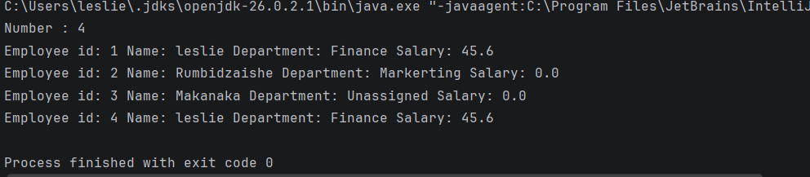
Output

- Intermediate: Predict the output of a class containing two static blocks and two instance blocks, then verify it.
Code
public class BlockOrder {
// Static blocks run once when the class is loaded
static {
System.out.println("First static block");
}
static {
System.out.println("Second static block");
}
// Instance blocks run for every object
{
System.out.println("First instance block");
}
{
System.out.println("Second instance block");
}
BlockOrder() {
System.out.println("Constructor");
}
public static void main(String[] args) {
System.out.println("--- First object ---");
new BlockOrder();
System.out.println("--- Second object ---");
new BlockOrder();
}
}

output
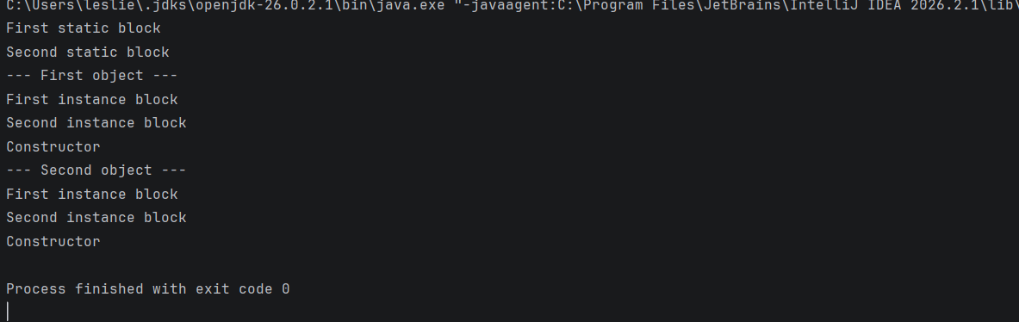

- Challenge: Implement a Temperature class with static factory methods fromCelsius(double) and fromFahrenheit(double) and a private constructor. Explain why static factories can be clearer than overloaded constructors.

Code
public class Temparature {
private double celsius;
// Private constructor
private Temparature(double celsius) {
this.celsius = celsius;
}
// Factory method for Celsius
public static Temparature fromCelsius(double celsius) {
return new Temparature(celsius);
}
// Factory method for Fahrenheit
public static Temparature fromFahrenheit(double fahrenheit) {
double celsius = (fahrenheit - 32) * 5 / 9;
return new Temparature(celsius);
}
public void display() {
System.out.printf("Temparature: %.2f Celsius%n", celsius);
}
public static void main(String[] args) {
Temparature t1 = Temparature.fromCelsius(25);
Temparature t2 = Temparature.fromFahrenheit(98.6);
t1.display();
t2.display();
}
}

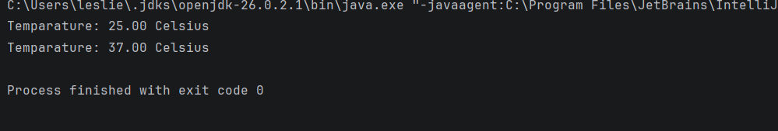
output

Explanation
Static factory methods are clearer because their names show what type of value is being used. For example, fromCelsius(25) uses Celsius, while fromFahrenheit(98.6) uses Fahrenheit.
The constructor is private, so objects are created through the factory methods instead of calling the constructor directly from outside the class.

